Part 1.1 - DSB-LC AM

1. Source Spectrum

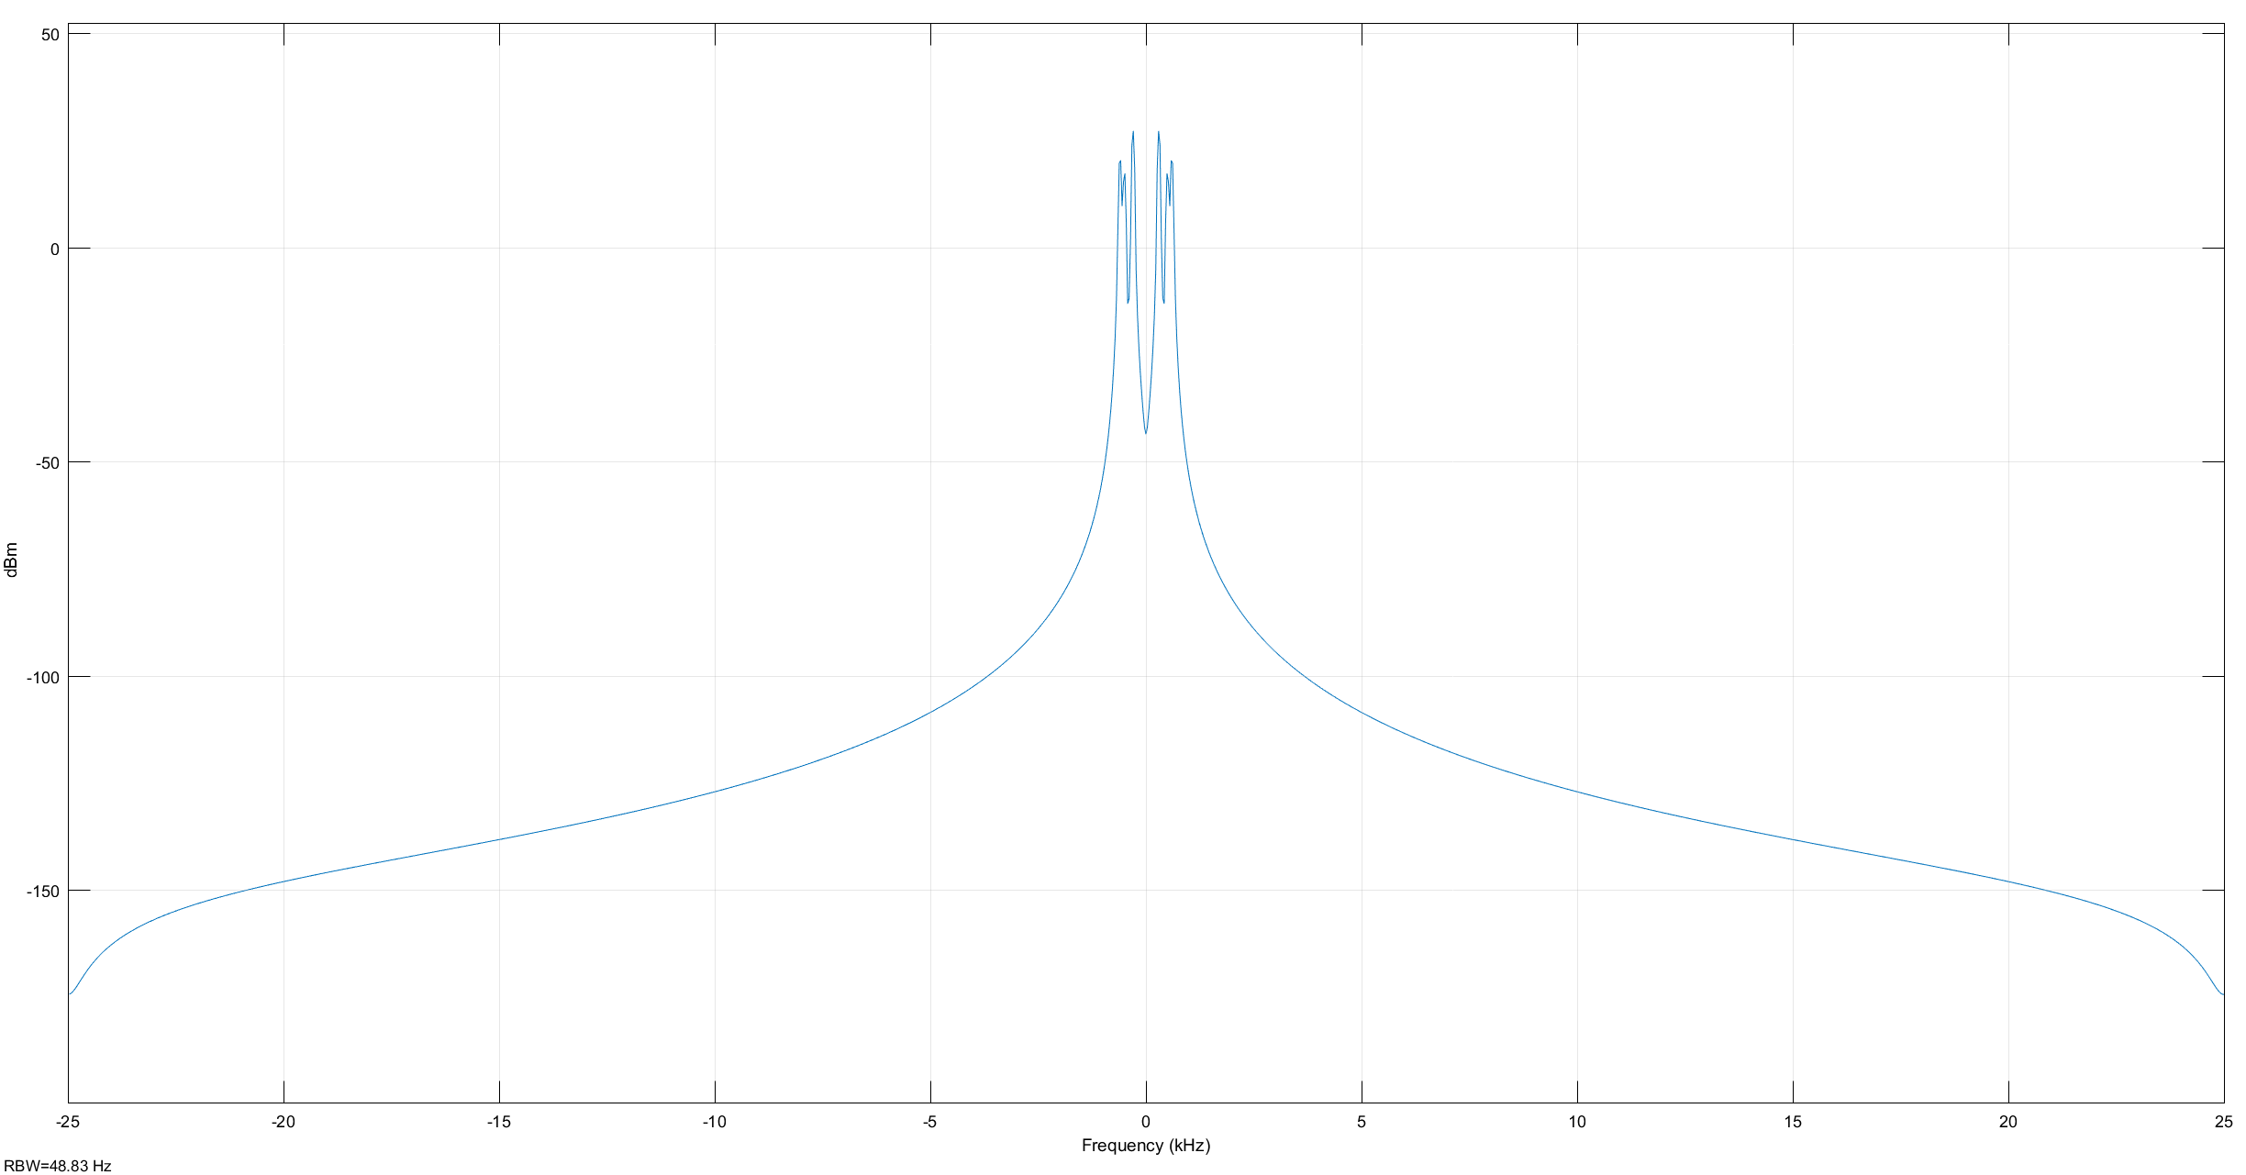

2) Source Scope

The one used in the lab report

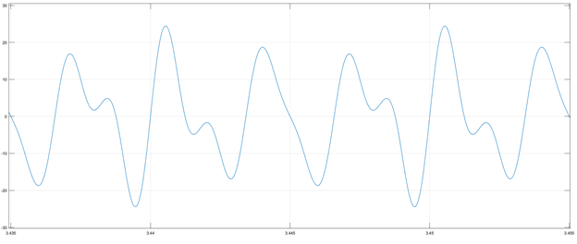

Not taken

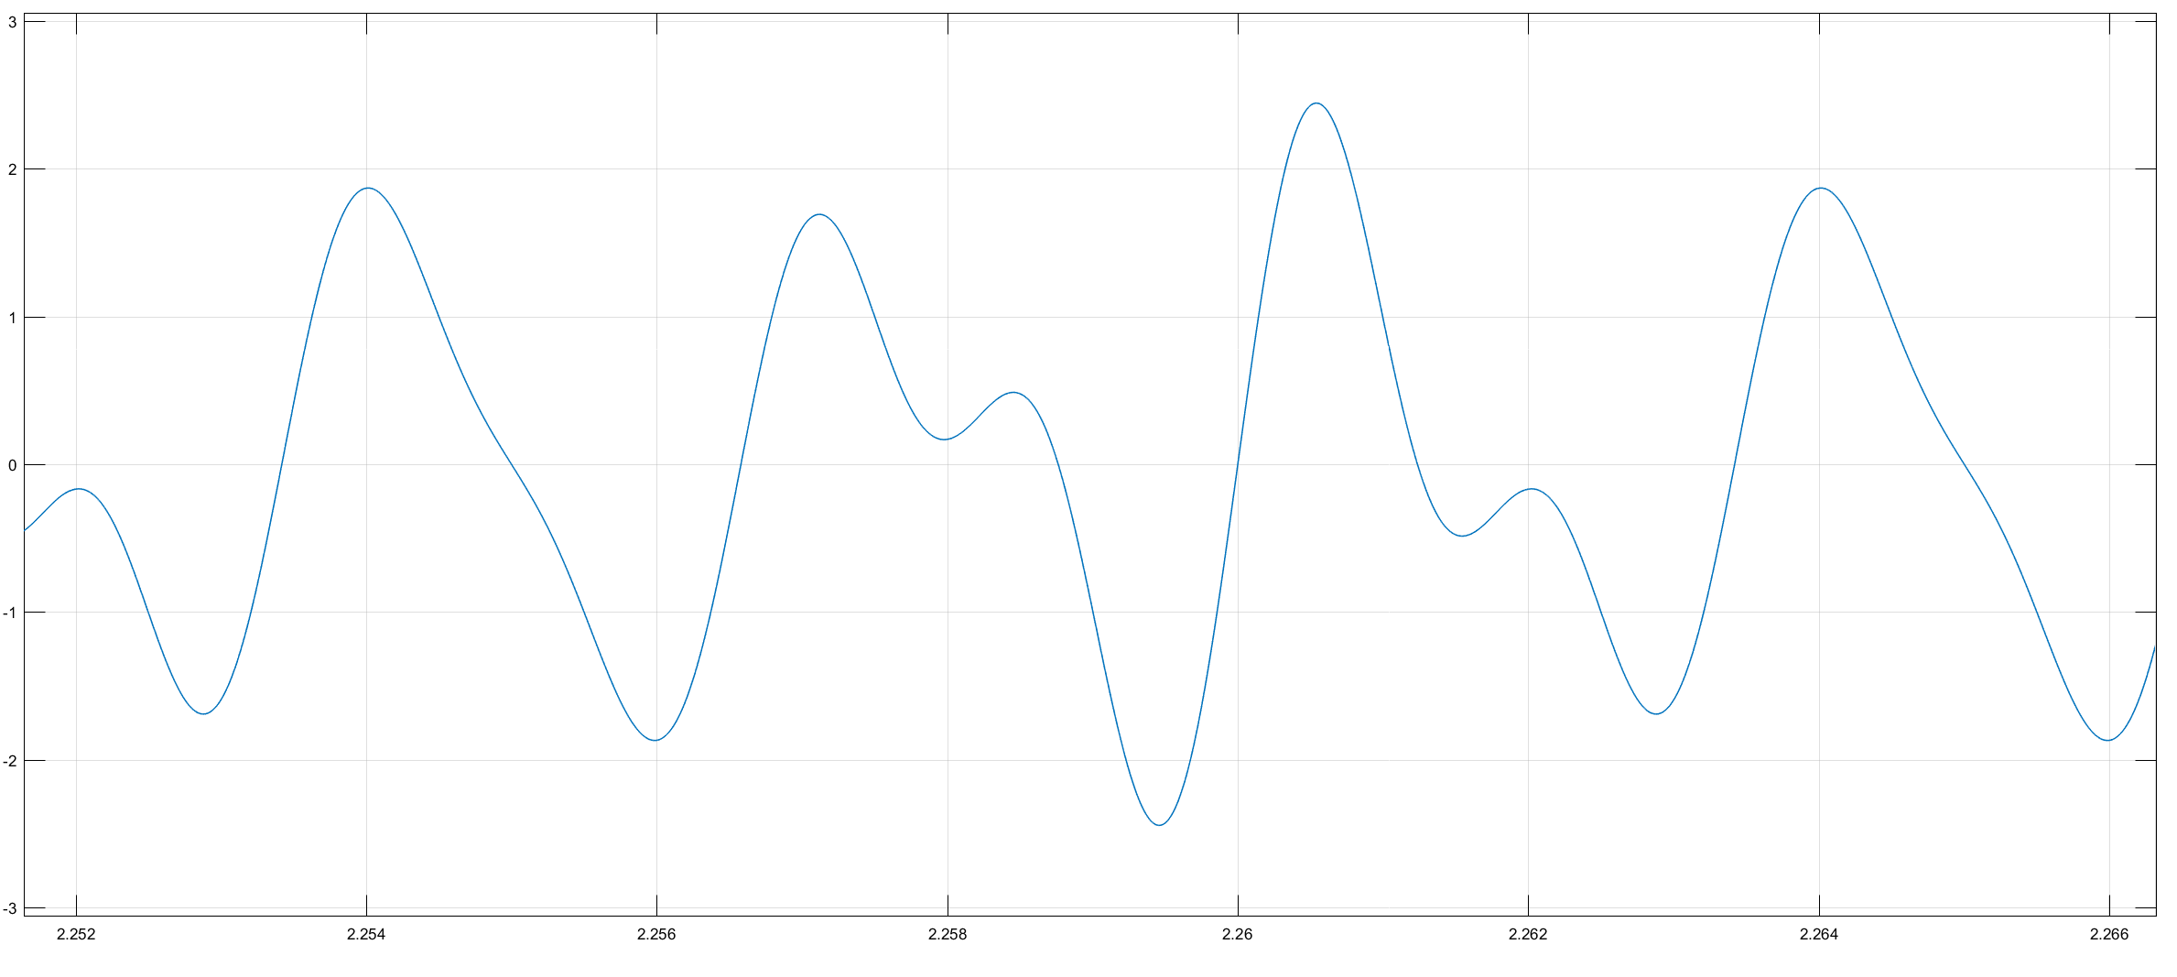

Scope Mod

Used in lab report

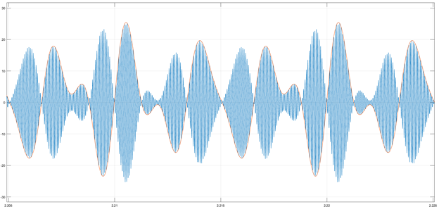

Not taken

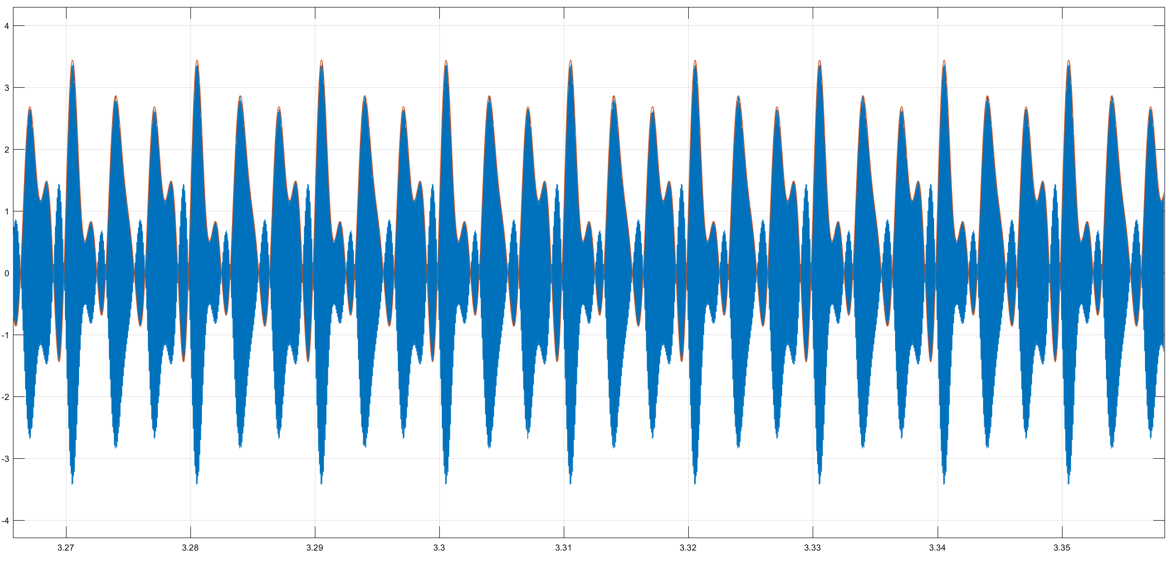

Make comment on the envelope that is in yellow compared to the blue signal

3) Spectrum Mod

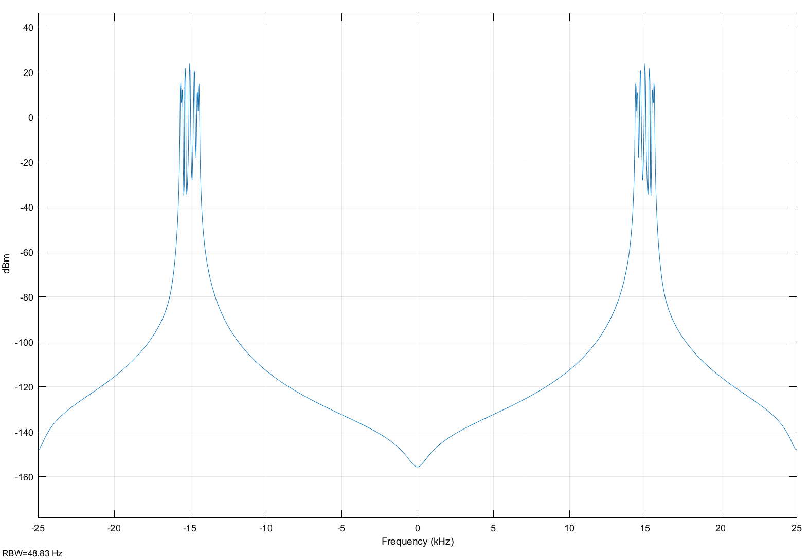

Use double side band, which is not as effective as simple side band, as the number of frequencies is larger.

4) and 5) Spectrum Output

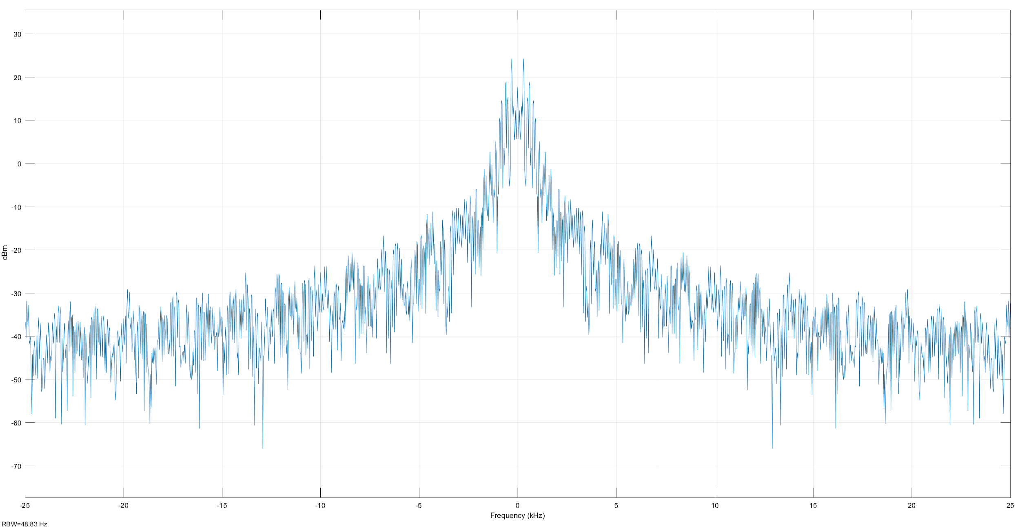

Spectrum BPF

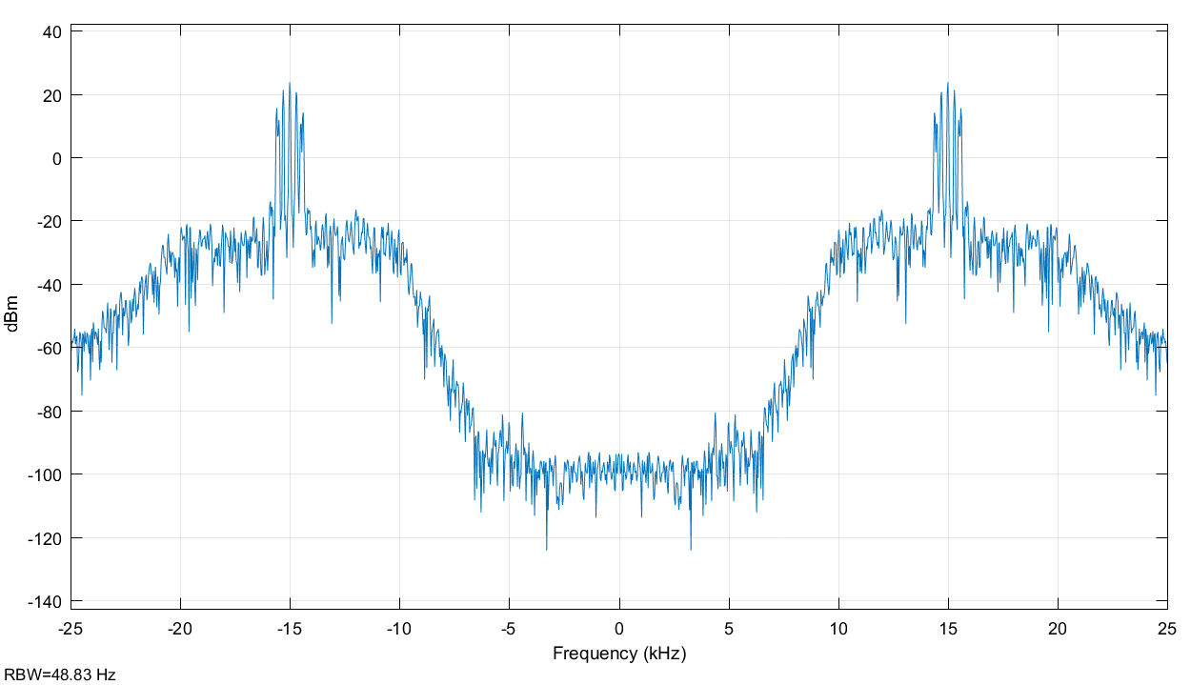

For question 4 and 5 we are going to compare Spec Out and Spec BPF for the answers.

6) Constant BIAS 10

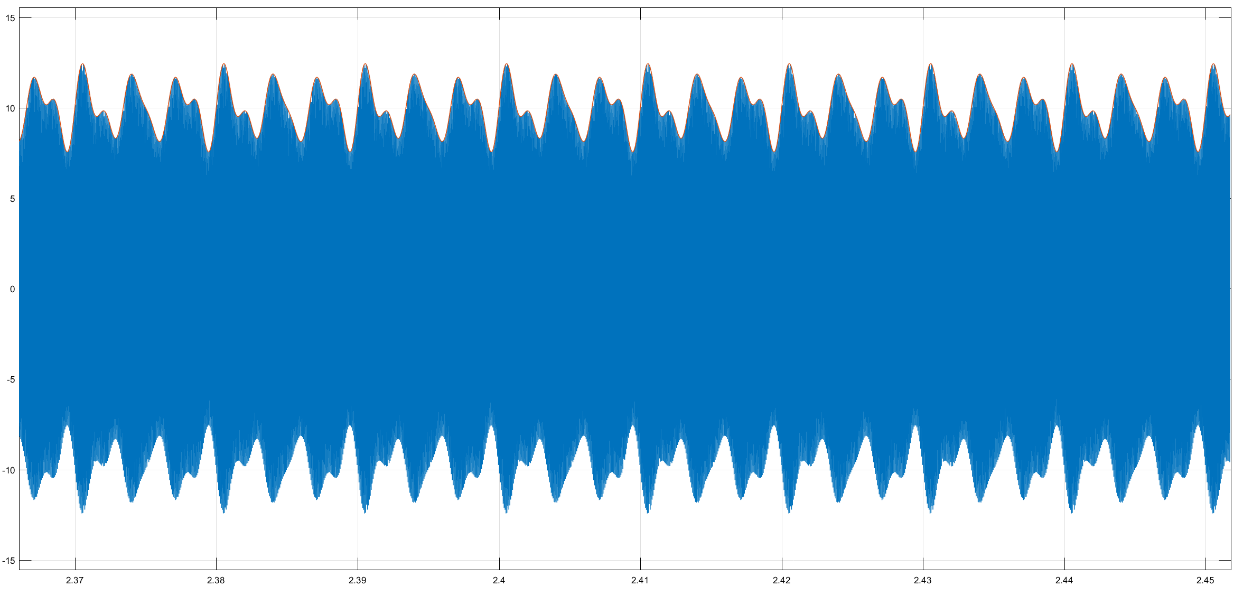

Gain = 5

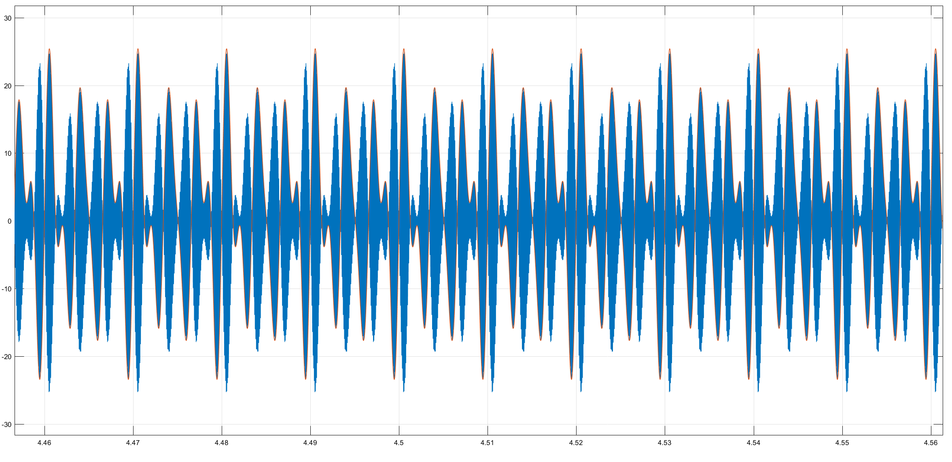

Idk yet…

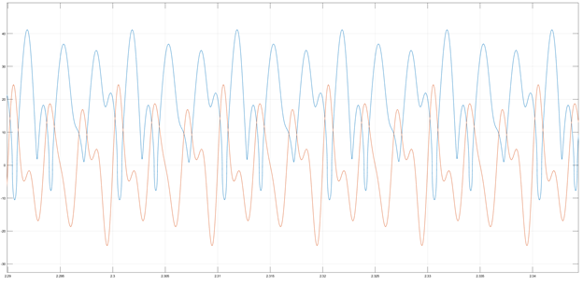

*Figure 7: Output scope for a gain of 20.*

*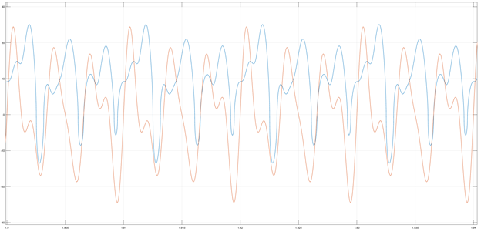*

*Figure 8: Output scope for a gain of 5.*

/\* Capacitor, resistor, and diode to have the peaks of the signal you want to transmit

Part 1.2 the signal goes up and down below the zero axis

In part 1.1 we added a DC constant of 1 to have it above the zero axis

Signal transmitted must be the same as signal emitted \*/

Cutoff frequency must be in the middle of the lower and upper frequency.

Part 1.2 DSB-SC AM

Q2

Scope Souce:

Correct one used in the lab report

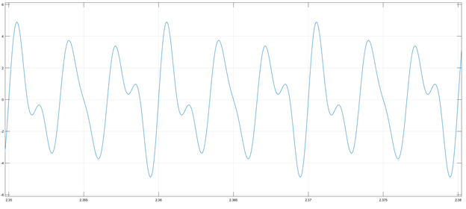

Not taken

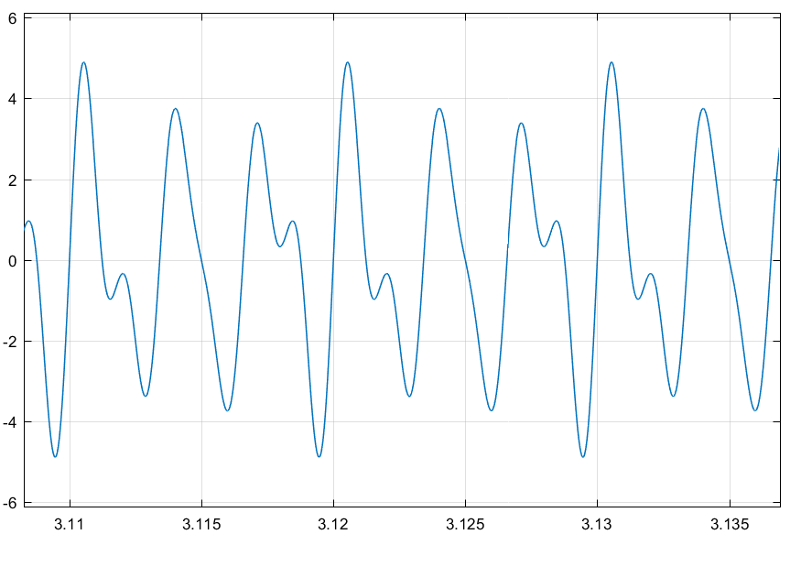

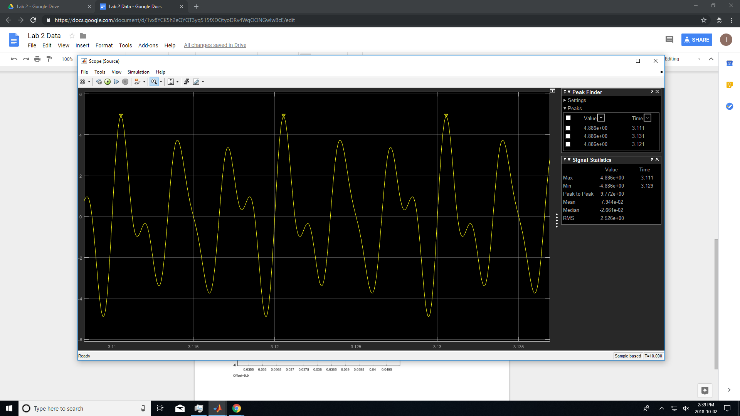

Scope Mod:

One used in lab report

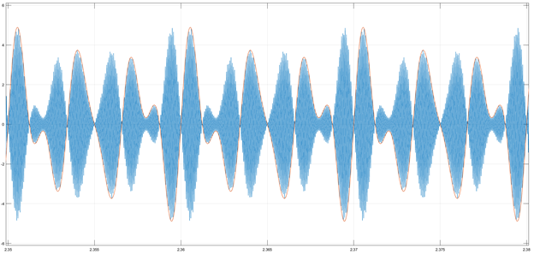

Not taken

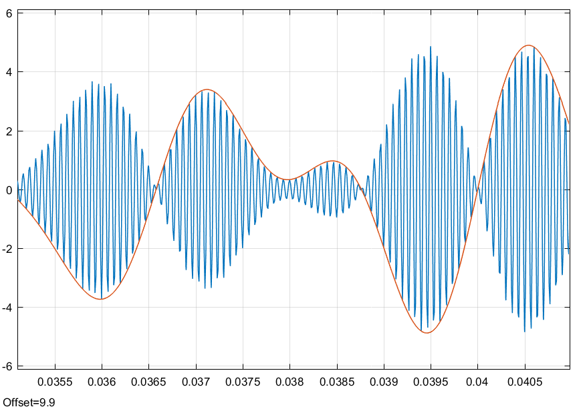

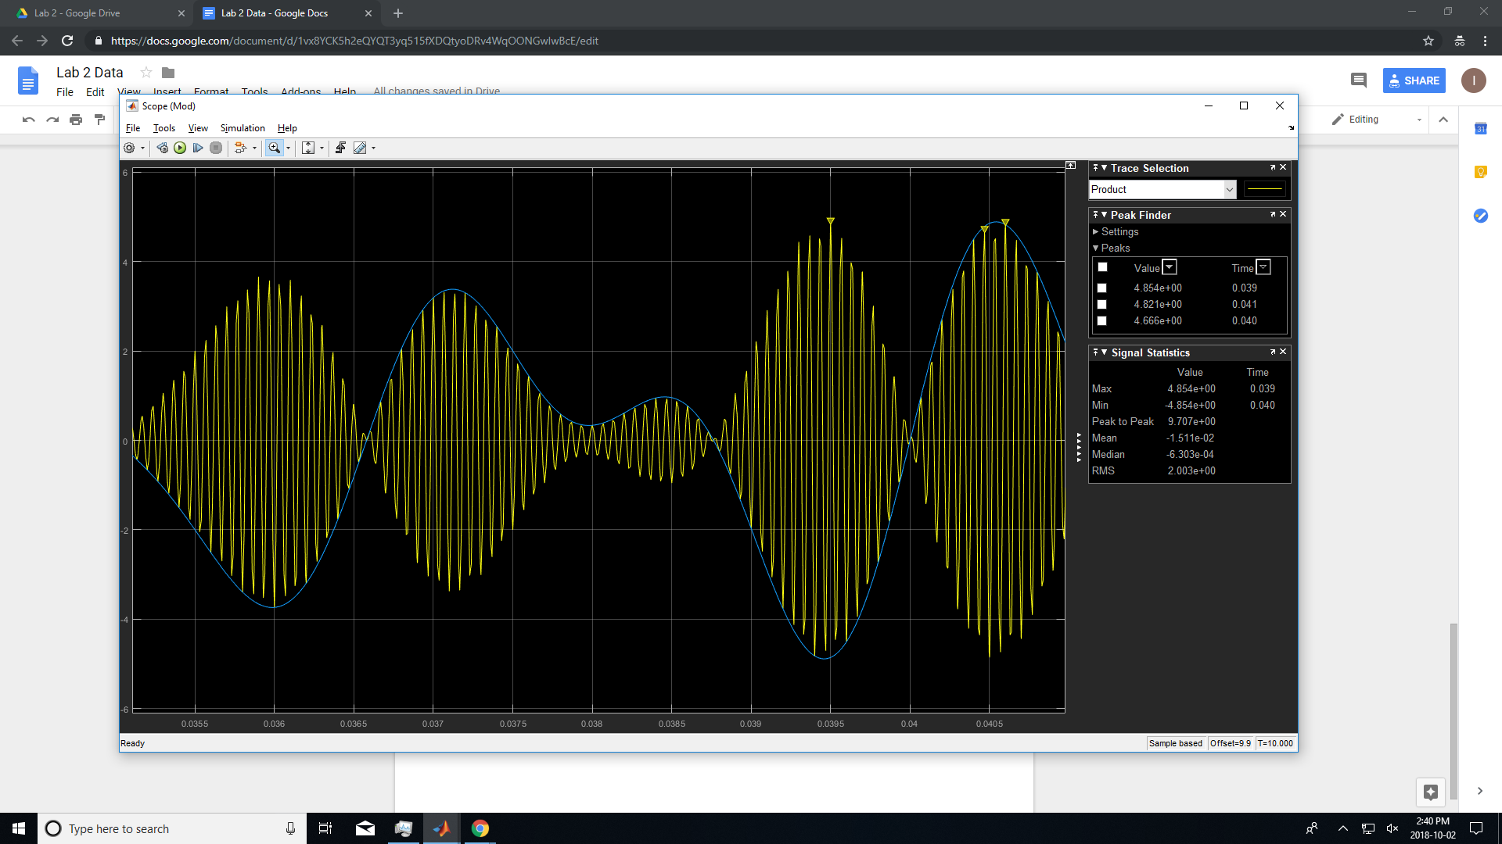

Q3

Spectrum Source:

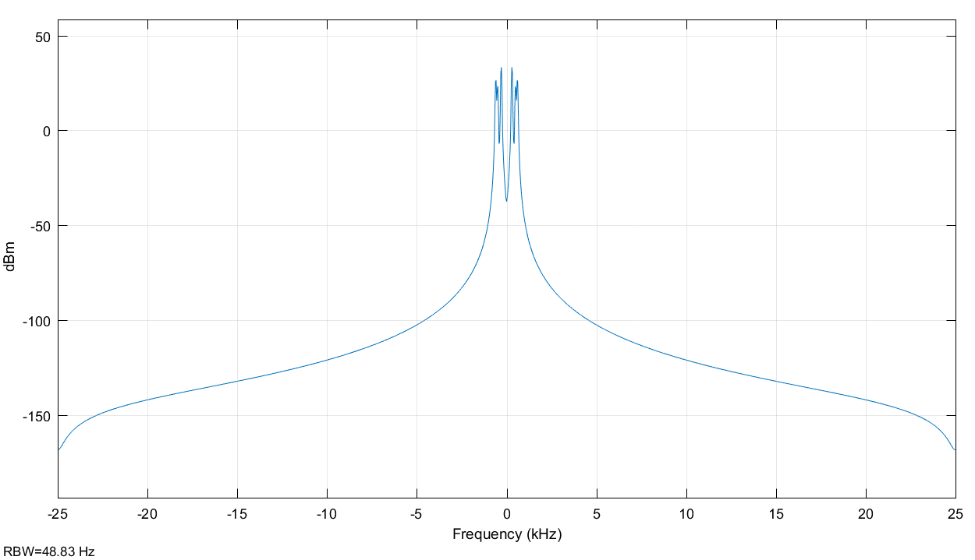

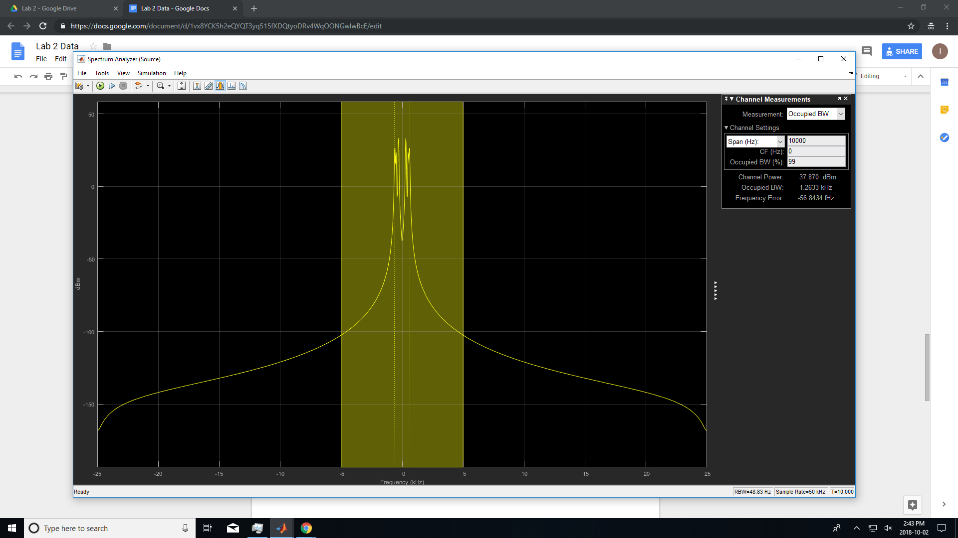

Spectrum Mod:

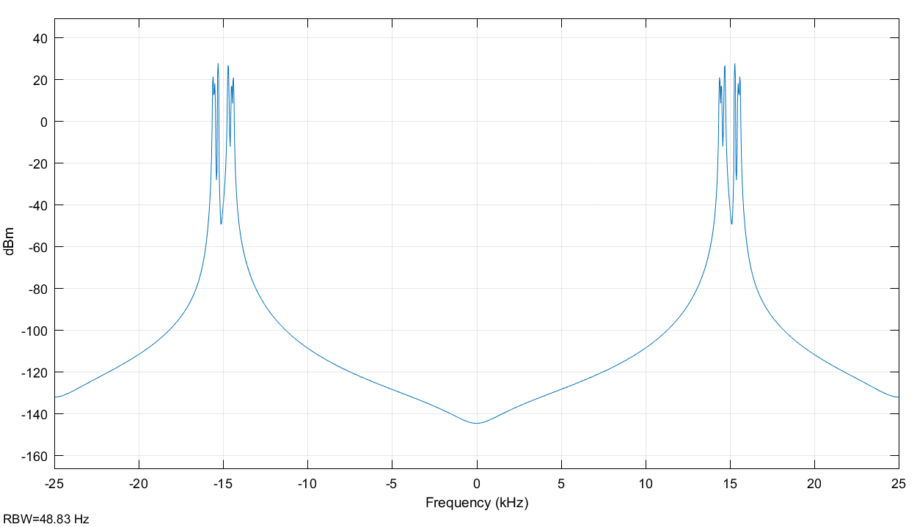

Spectrum Output:  
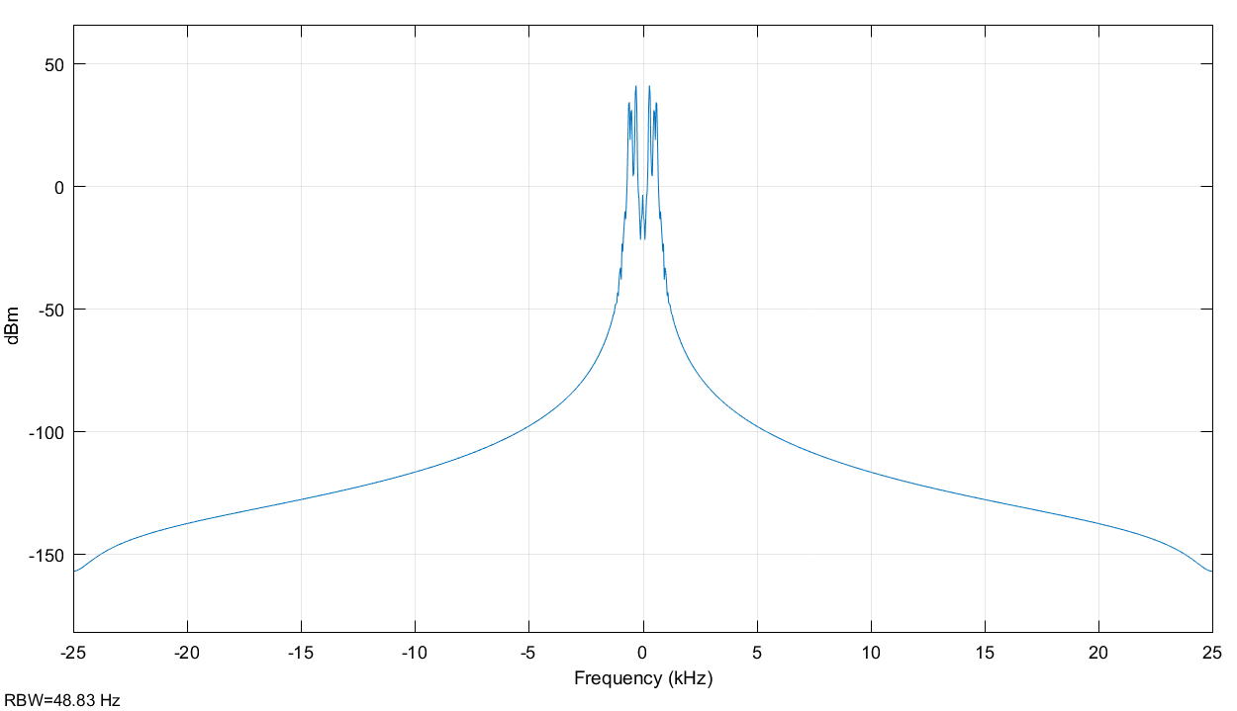

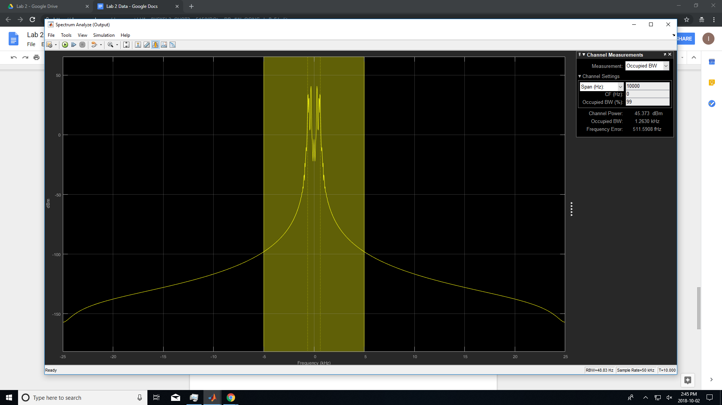

Part 2 FM System

Here with a gain of 150 and a constant of 300 to have better visuals.

Part 2.1

Close loop, same phase as the signal input,

Close loop is different than feedback,

1. Mathematical description, very basic
2. Scope Mod

Gain = 150

Time period = 0.2 s

3) Beta = Gain (Sensitivity Factor) / Constant (Carrier Frequency)

Gain = 600

Time period = 0.2 s

Blue: signal

Red: carrier frequency

the amplitude of carrier frequency stays the same whereas the frequency

Part 3

Carrier frequency around 30k with gain is 150 and the bandwidth is really small. Very sensitive to noise. If increase gain to 15000 the bandwidth is much greater. Larger bandwidth, much greater resilience, not affected as much to noise. Thus, there is a compromise between bandwidth and performance. Expected frequency to be much more.

As delta f increases, the bandwidth also increases.

